**Dataflow-3(joins,sort,pivot)**

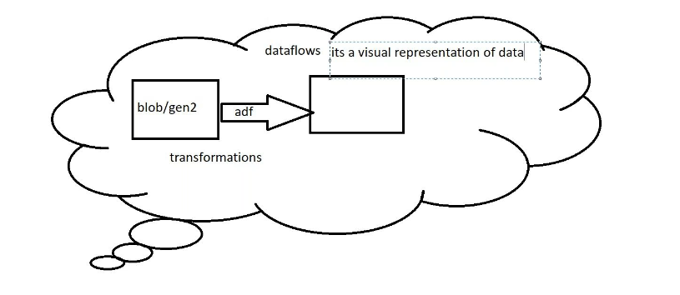

Create blob storage source side:

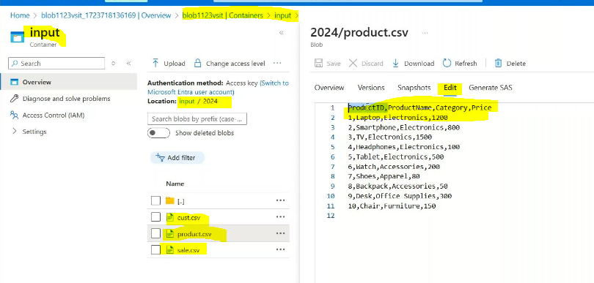

Create gen2 storage sink side :

Output container:

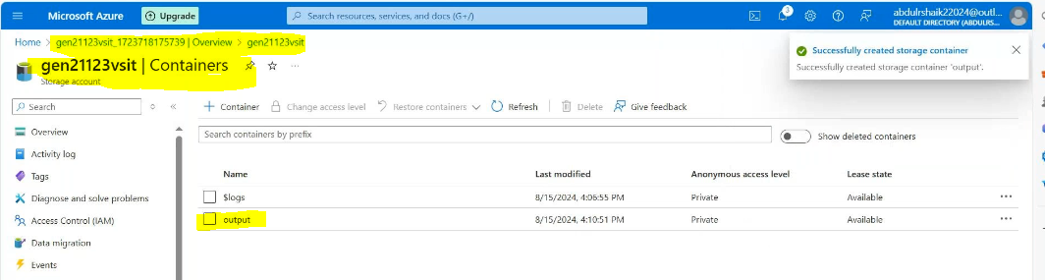

Create linked service fro both:

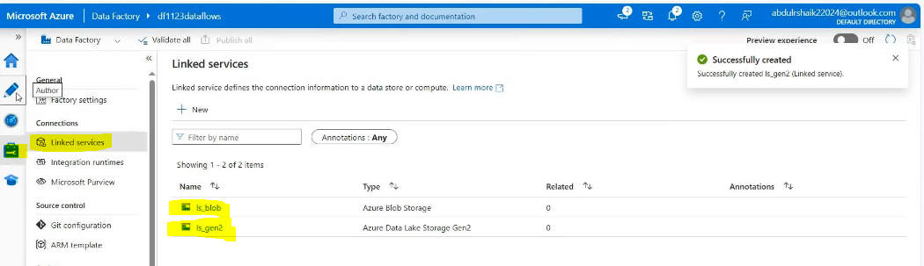

Create 3 dataset for 3 files:

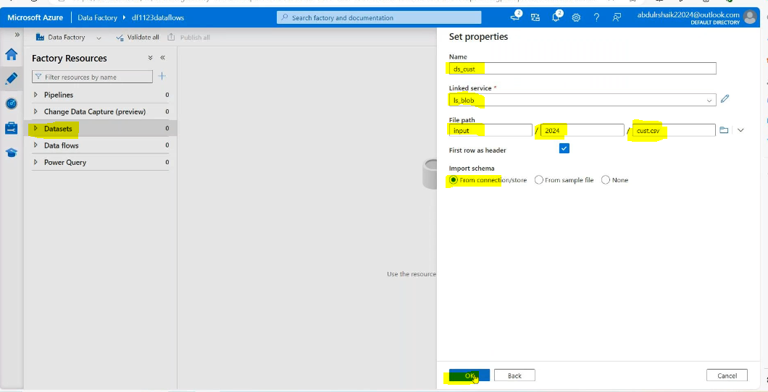

2nd dataset:

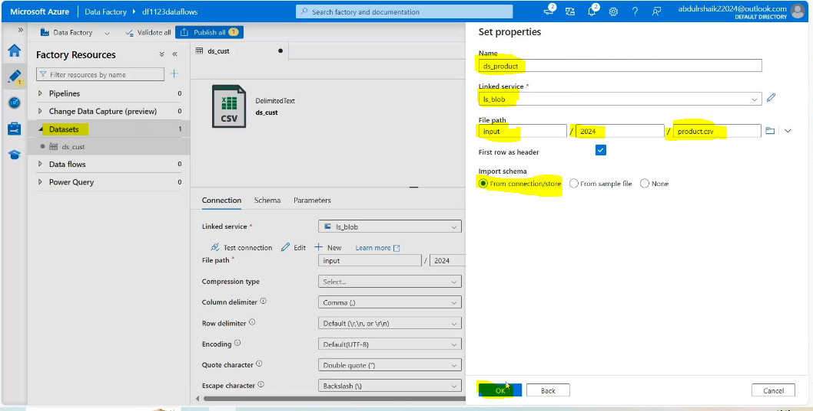

3rd data set:

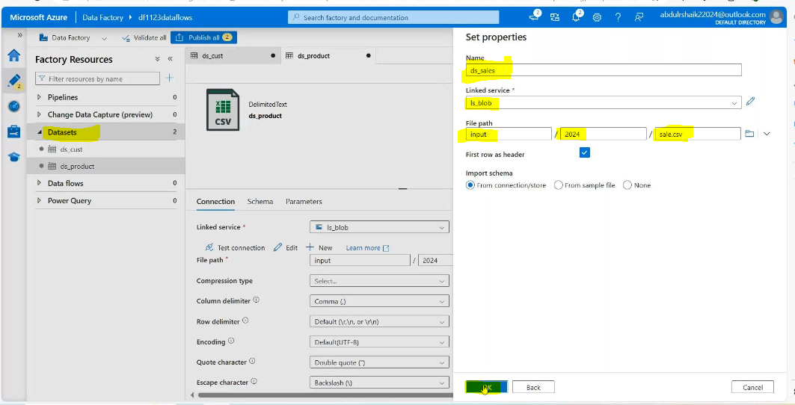

Create dataflow_joins

Then Add 3 sources: parallel like the below and named it

Add the data settings in 3 sources:

Enable the Debug mode:

Join 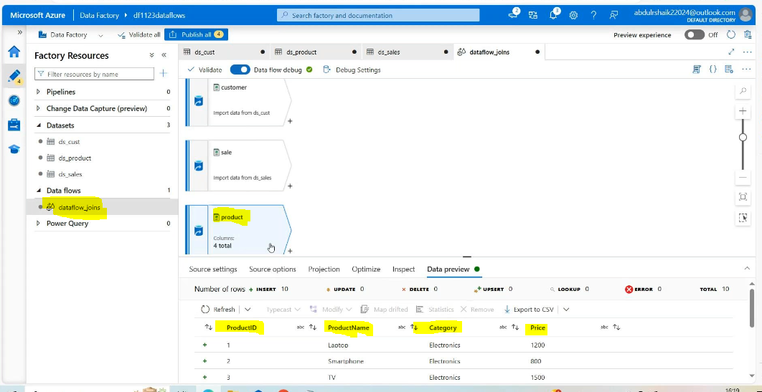

Join: join is technic it is used to join the two or more tables by using the comon column in that tables

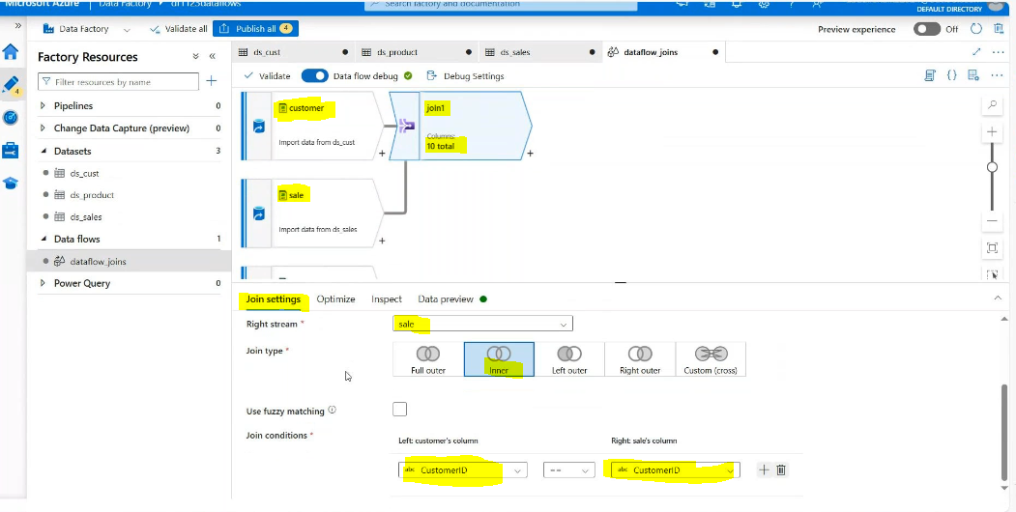

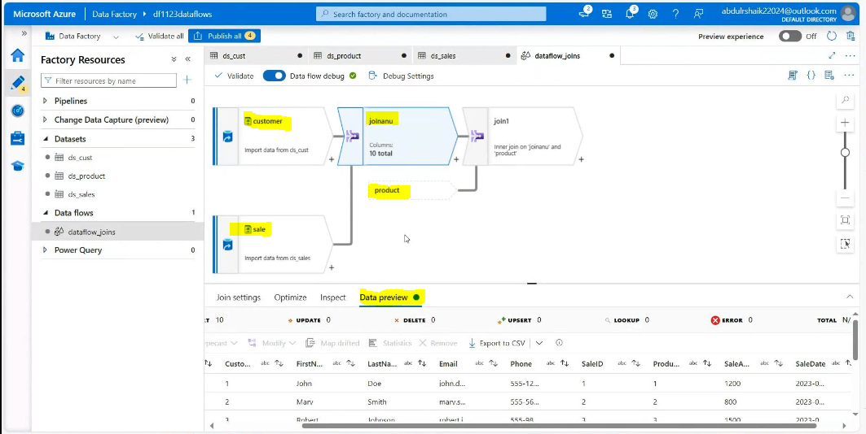

Customer and sales join result is joining with sales data:

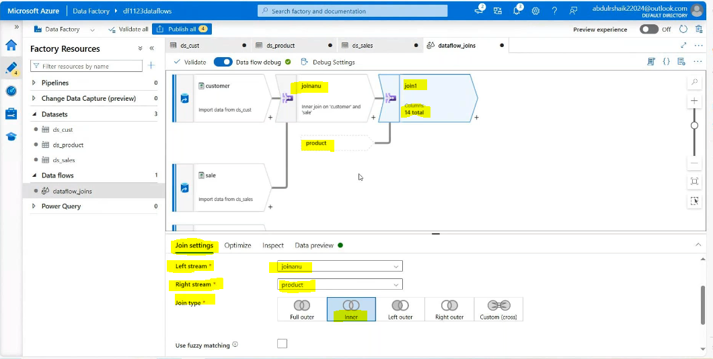

Comon cloumn is

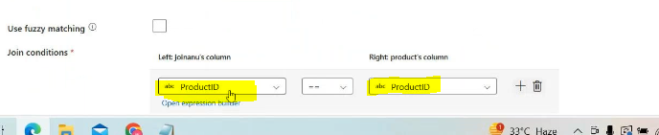

Then add select source: By using this add or delete the columns

In thi swe need customerid,saleid,productid,saleamount,saledate,category,price then except these delete all the things

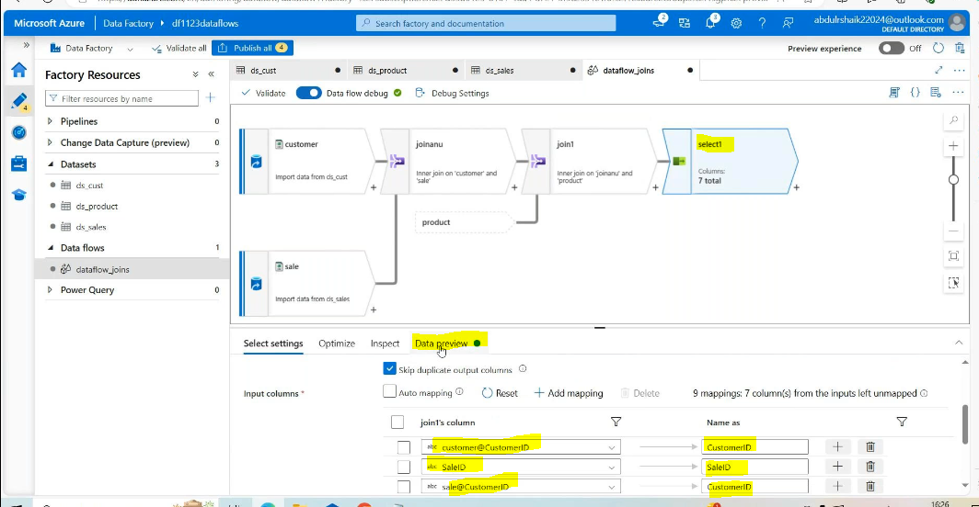

Add source sink side:

Create dataset for sink side:

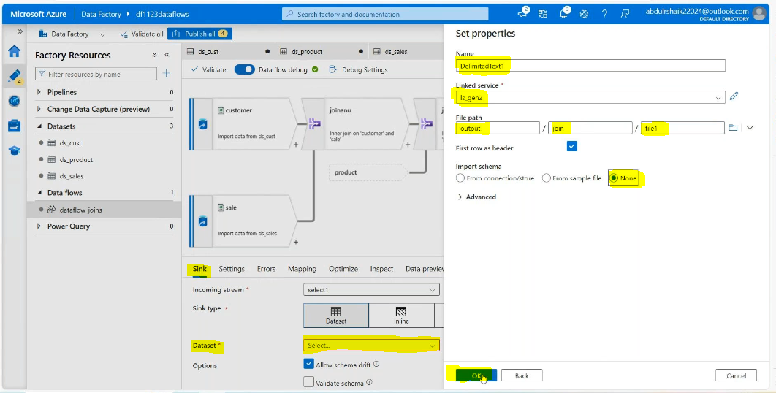

Then sort concept:

Create dataflow sort

Add file in blob storage:

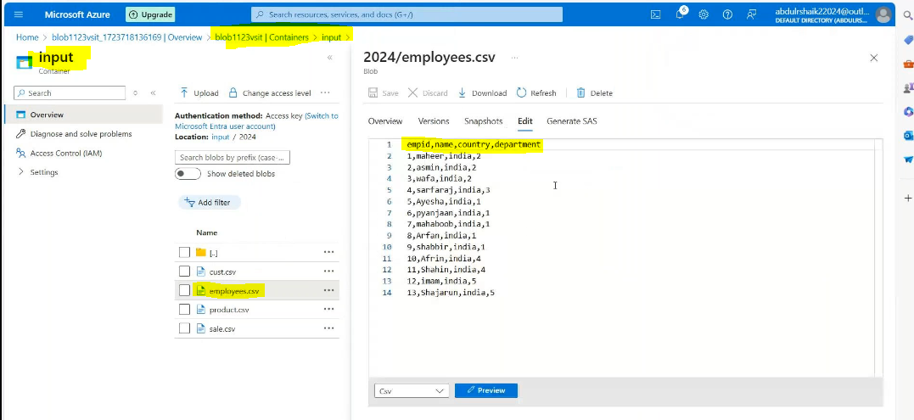

Create dataset for this file:

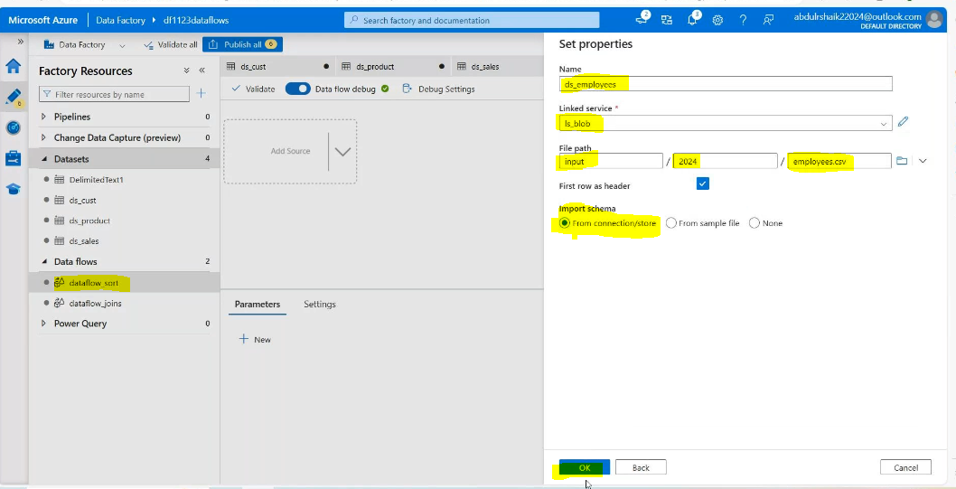

In datflow:

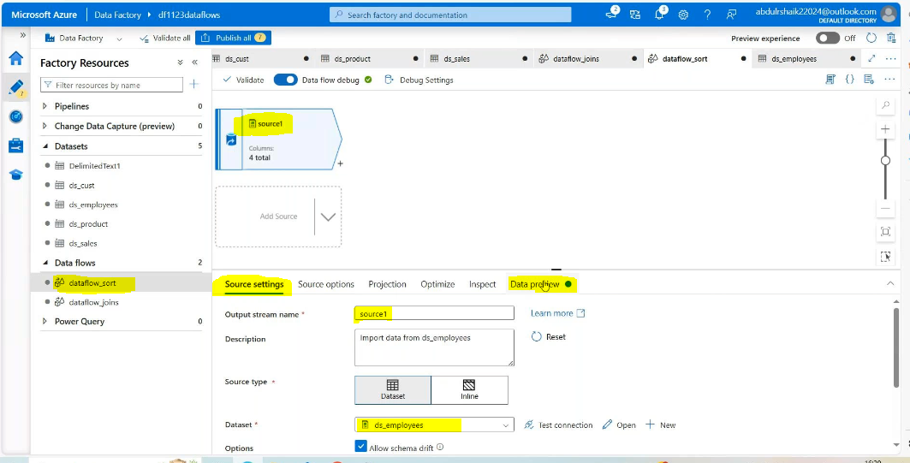

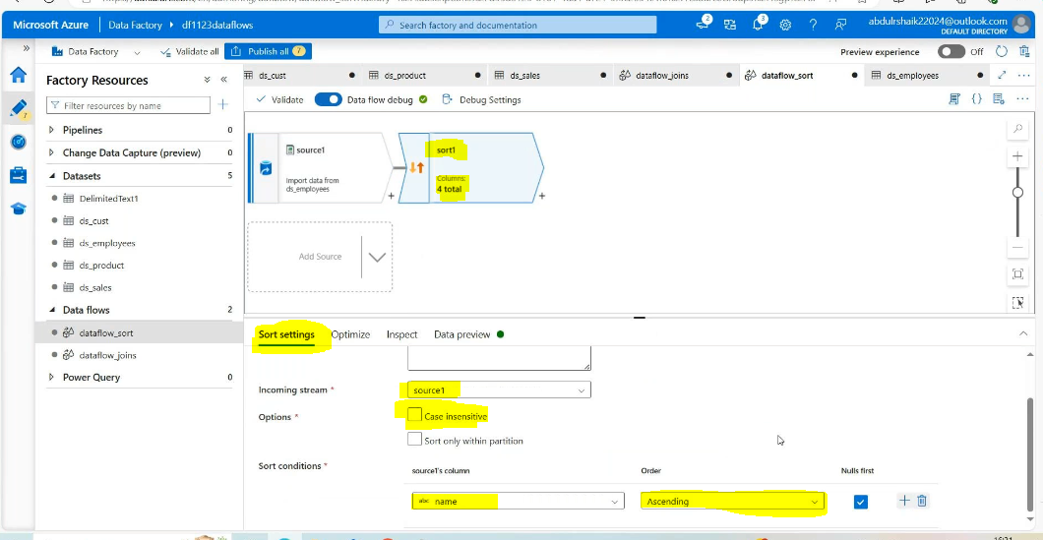

Datapreview:

Then add source as sink:

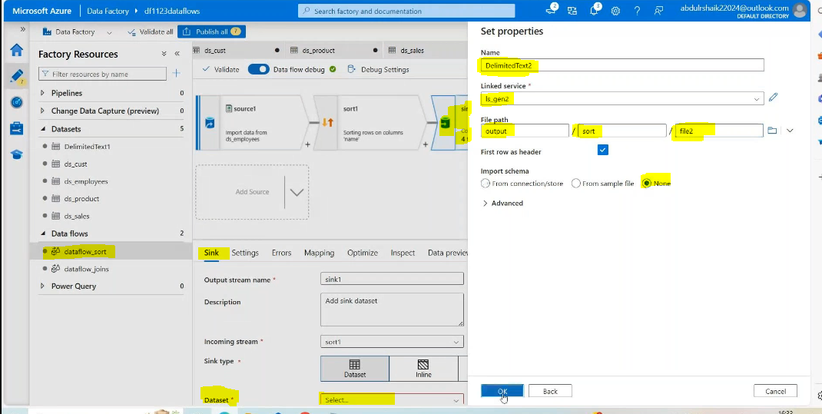

Pivot concept:

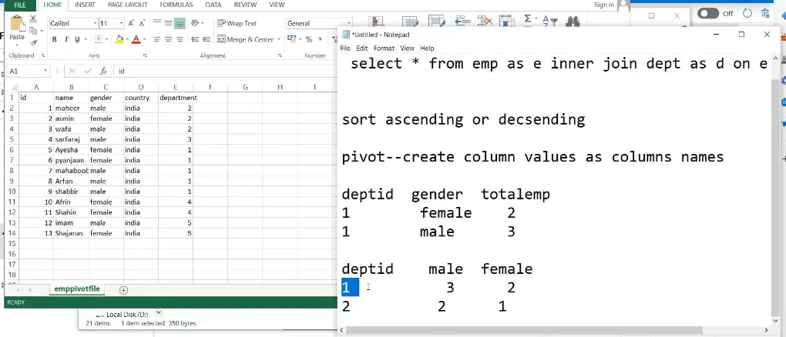

Upload this fiile into the blob storage:

Create 1 dataset for this file:

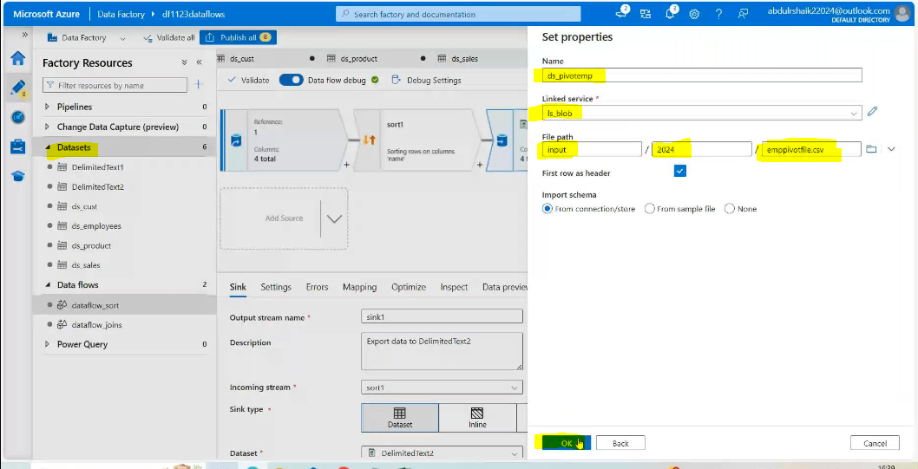

Create 1 dataflow fro pivot:

Add source

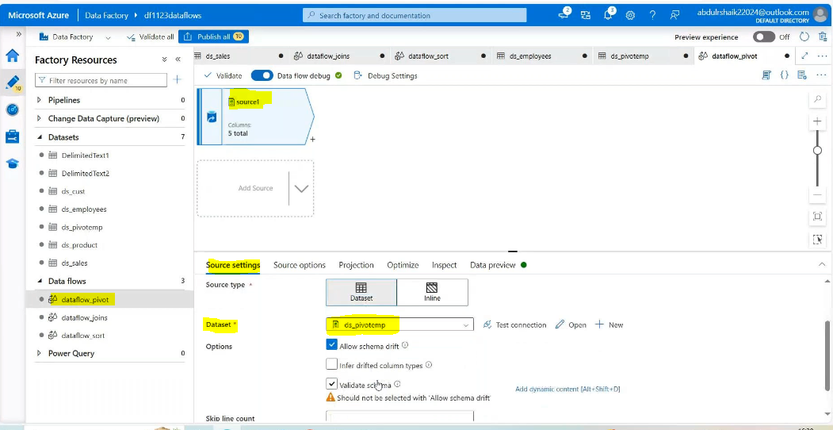

Data preview:

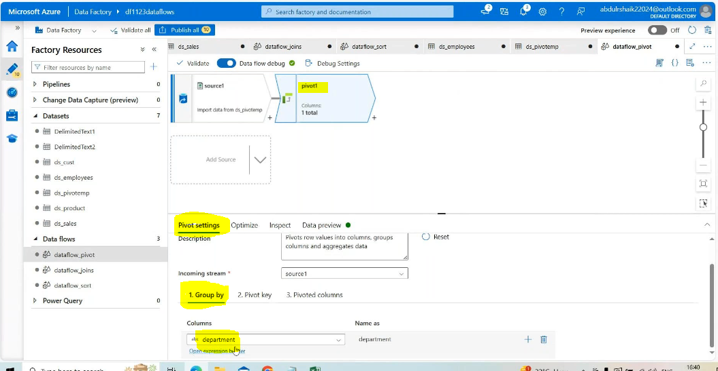

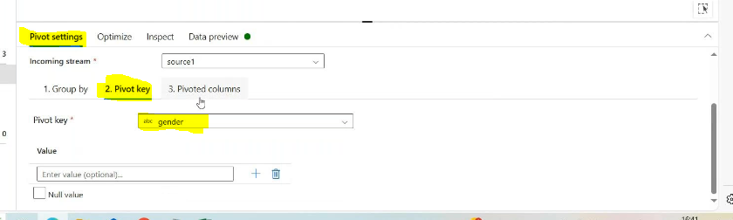

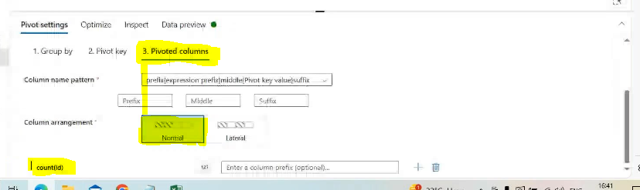

Datapreview:

Then Add sort source:

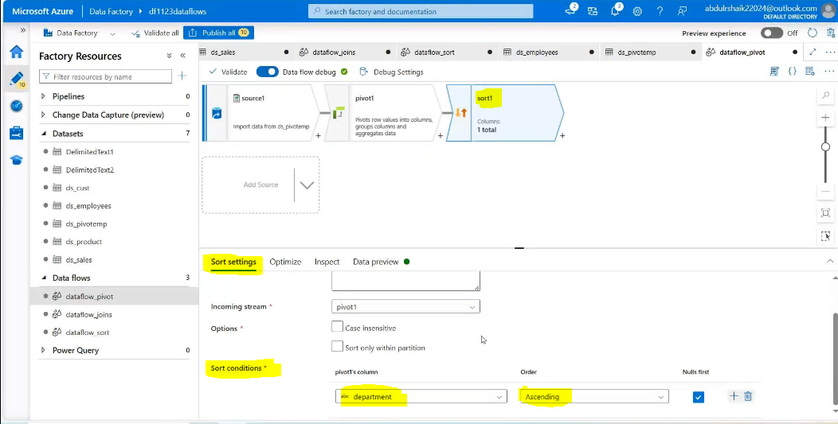datapreview:

Create dataset for sink side:

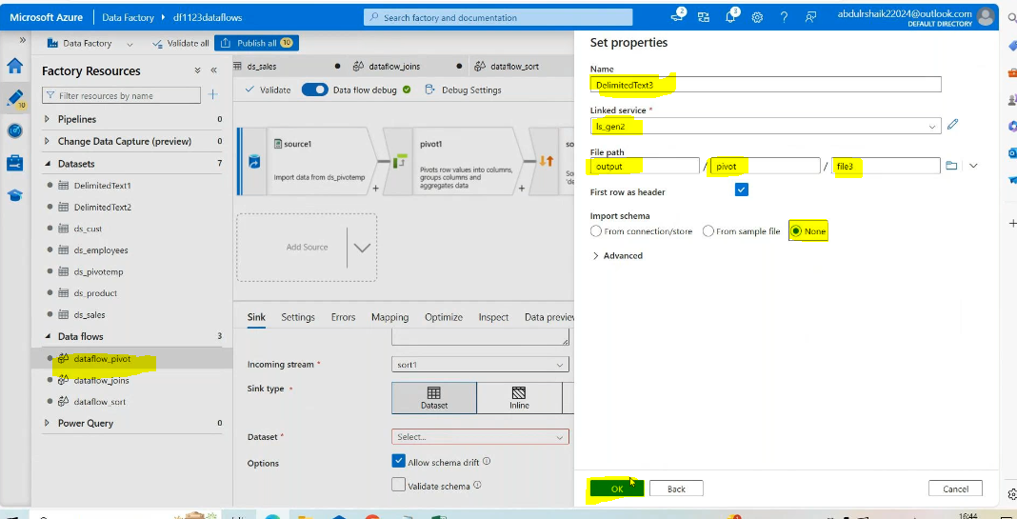create pipeline:

Drag 3 data flows: in sink side:

Valiadate pipeline and debug

Result:

